**VariaMos web architecture**

May 2019

The VariaMos team

The VariaMos web architecture is divided in three main views. Front-end development view, server view, and client view.

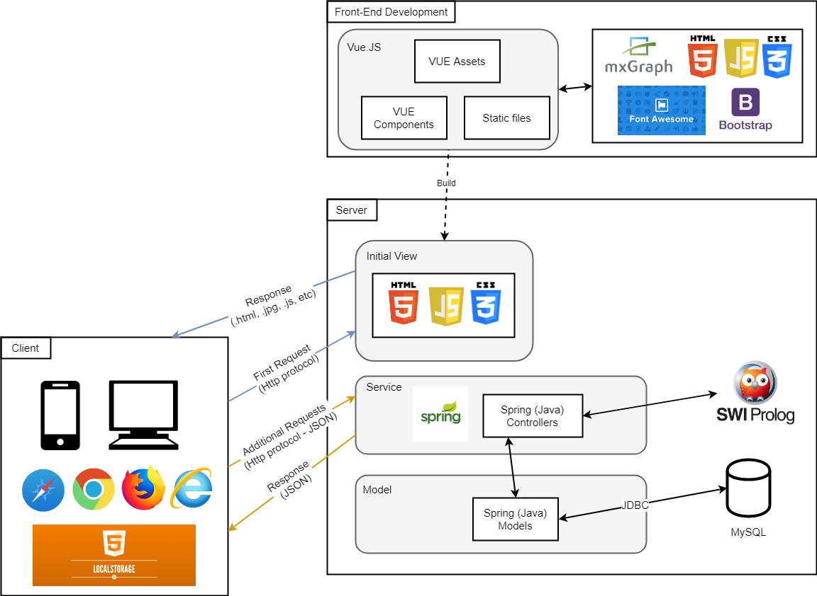

**Front-End development view**

This view represents the VariaMos web repository. <https://github.com/SPLA/VARIAMOS-WEB/tree/development>

**Some main characteristics of this view are:**

* The use of MxGraph to create the graphical models: <https://github.com/jgraph/mxgraph>
* The use of bootstrap as the main CSS framework: <https://getbootstrap.com/>
* The use of CSS3, HTML5 and font-awesome for the web design.
* The use of VueJS 2.0 which defines the main architecture. In which the different sections of the web application are represented as “vue views” and “vue components”  
    
  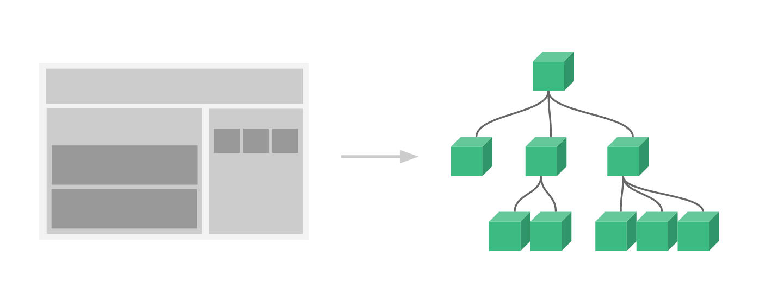
* Each vue view and vue component (vue files) follows the vue lifecycle: <https://vuejs.org/images/lifecycle.png>
* Each vue view and vue component (vue files) contains three sections (HTML section, Script section, and CSS section):  
  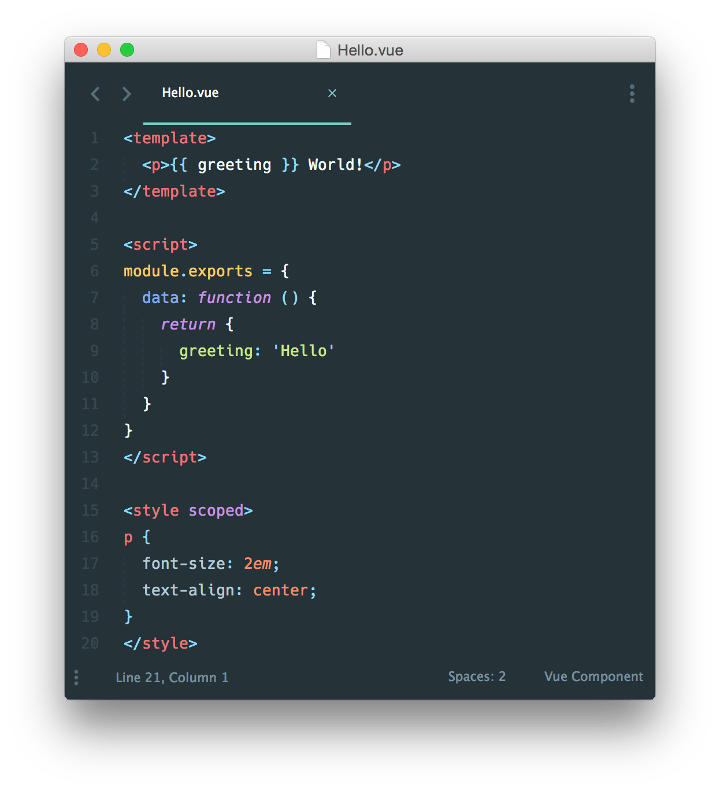

**Server view**

This view represents the VariaMos server repository. <https://github.com/SPLA/VARIAMOS-SERVICES>

**Some main characteristics of this view are:**

* The use of Spring MVC which defines the main architecture <https://docs.spring.io/spring/docs/current/spring-framework-reference/web.html>
* Spring MVC already contains a workflow that explains how it works internally.  
    
  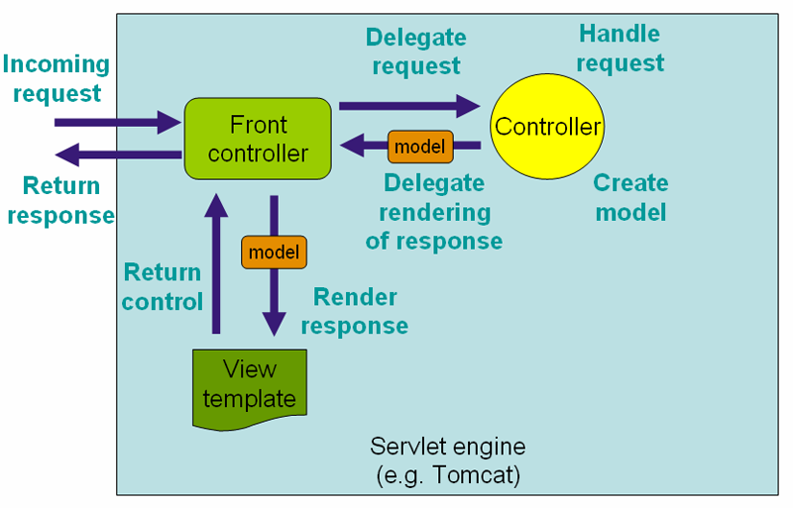
* The Spring front controllers were modified to act as services. And the view templates are not used, because the services only deliver text messages or JSON elements.
* We also plan to include the use MySQL and SWI-Prolog in upcoming versions.

**Note:** “the initial view” (check first image in this document) can be deployed in the same server that contains the VariaMos services, or it can be deployed in another server.  
  
**Client view**

This view represents the application that is accessed by the client. One example of that application can be found here: <https://variamos.com/variamosweb/>

This application is build based on the Front-End application code through the use of NPM.